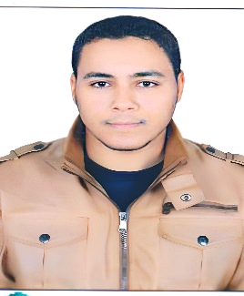
AHMED ABDELHAMID MOHAMED ASRAN
MOBILE : +201011643906
Passport Number: A09123803
Email:aabdelhameed238@gmail.com
Adress: QENA,Qena,Egypt

OBJECTIVE
I do my best to be in the career which I find myself and develop it .
Personal Details
Gender : Male
Date of birth : 01/01/1989
Nationality : Egyptian
Marital Status : Single
Military Status : finished
Job Experience
-Coordinator at international tubular service from 2012 to 2014.
- training coordinator at egyptian railway.
- English language trainer at many centers and online

EDUCATION
Bachelor degree in economics and political science 2010 cairo university , from faculty of economics and political sciences for four years.
COURSES
- fire fighting course.
- first aid course.
- customer service .
- training specialist.
- english courses.
- icdl course.
-digital transformation course.
Skills
-flexibility in dealing.
-physical skills.
-fast learning.
-strong in observation.
- Ability to work more than 12 hours in day.
Language and computer
- arabic: ( native language).
- english : excellent ( speaking , writing , reading , and listning ).
- computer : very good at microsoft office (windows , word , excel and power point ).
Field of interest
* english language

Thanks a lot,

