Personal CV
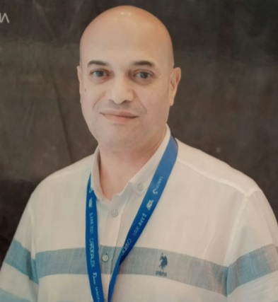

Name: Usama Hassan Hassan Salama
Date of birth: 14 -1-1967
Country: Egypt- Alexandria
Mobile : 01005025656 - 01143474810 - 01200040386
Marital status: Married, I have two sons and one daughter.
E-mail: usamahassan14@yahoo.com
Qualifications:
- Financial Accounting Doctorate. (Florida University of science USA). (Jan 2020).
- Master degree in international transport and logistics (Arab Academy for science and technology (Alexandria 2007).
- Faculty of commerce graduate, Alexandria University- Accounting branch (May 1988).
- Language school graduate (El Nasr boys’ school) fluent in English language.
- Fully aware of computer skills.
- Working as corporate administrative manager for Holding company for maritime and land transport More than 20 years.
- My experience is focused in these areas:
- Financial analysis of financial statements of maritime companies (container co- cargo co- transport co).
- Preparing analytical financial reports recommendations using financial ratios.
- Corporate performance evaluation of companies.
- Follow up the implementation of the companies estimated budgets regards to their future planning also follow up on distractions.
- Preparing financial recommendations for the future visions of companies how to make more profits or reduce losses.
- Participation in the financial business of the liquidation and merger committees of the companies.
- Participation in preparing feasibility studies that aims to objectively and rationally uncover the strengths, weaknesses, opportunities and threats present in the natural environment, the resources required to carry through and ultimately the prospects for success.
- How the companies can attract maritime liners regarding to (service-time-cost) to increase their market share.
- Participation in attending the general assemblies of companies every financial year.
Beside that:
- I taught commercial subjects (marketing-investment- accounting – future planning) to university students in private centers.
- Participate in google programs on the internet especially digital marketing point of view.
- Looking for everything new (on the internet) about financial researches news.
- I can work under pressure and I have the ability to change and develop quickly.

~~~~~~~~~~~~~~~~~~~~~~~~

